Exporting your RefWorks library
It’s easier than it sounds to export your references for use in another citation manager! Follow these instructions, and visit the reference desk or call 216-687-5300 if you have any questions.
1. To export ALL references, mouse over References and click Export.
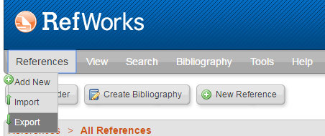
3. Choose Bibliographic Software as the export format and click Export References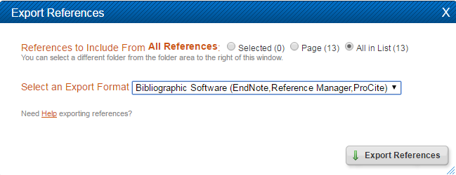
4. Download the .txt file that is created. You may have to Click Here and either Right Click – Save As text file that opens, or File – Save As to download the .txt file.
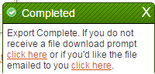

Your folder structure cannot be exported to another citation manager. For directions on exporting individual folders, view other side.

1. For each folder you want to export, right click the folder name in the folder view.
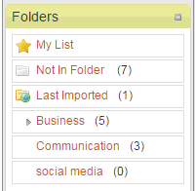
2. Click Export
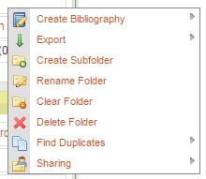
3. Click Bibliographic Software
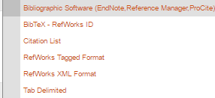
4. Download the .txt file that is created. Repeat for all folders you wish to export.

